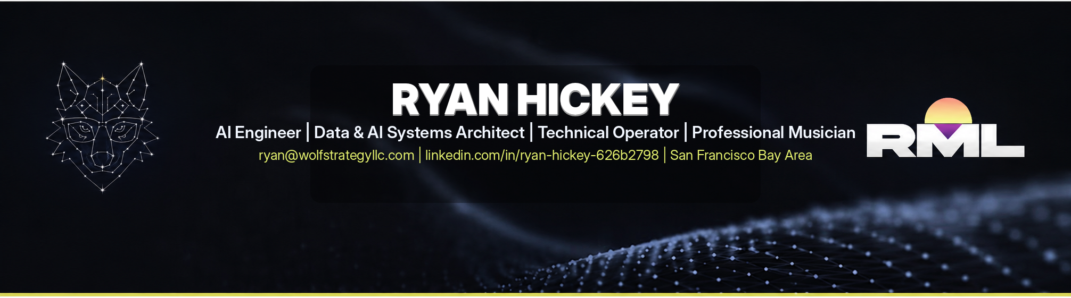
PROFESSIONAL SUMMARY
AI engineer, data scientist, software developer, technology operator, and professional musician with 20+ years of coding experience and 14+ years leading technology, analytics, and operational initiatives. Combines deep expertise in software architecture, Python development, SQL, cloud analytics, automation, and systems design with modern AI development workflows using Claude Code, OpenAI Codex, ChatGPT, and GitHub Copilot.
Known for designing and delivering production-ready data science software, internal tools, workflow automation, and decision-support systems through AI-accelerated development practices. Brings a rare combination of technical leadership and real-world music industry experience, including over 30 years of piano performance, 20+ years of studio production, sound design, recording, DJ performance, and music technology workflows.
After spending two decades building software, analytics, teams, and business systems, I am now intensely focused on mastering the emerging discipline of AI engineering through continuous hands-on experimentation, public software projects, formal technical training, and helping define how humans and intelligent systems build together.

CORE EXPERTISE
AI Engineering & Agent Development  Prompt Engineering • Claude Code • OpenAI Codex • ChatGPT • GitHub Copilot • AI Agent Design • Workflow Automation • AI-Assisted Software Development • Rapid Prototyping | Software Engineering & Architecture  Python • SQL • dbt • BigQuery • VBA & Advanced Excel • Data Architecture • Cloud Analytics • GitHub • CI/CD • Systems Design
Product & Operations Leadership  Technical Project Leadership • Notion AI • Cross-Functional Team Management • Strategic Planning • Operational Scaling | Music Technology  Ableton Live • Cubase • Reason • Pro Tools • Traktor • Reaper • MIDI Systems • Studio Production • Sound Design • Audio Engineering • Synthesis • Large Plugin Collection (FabFilter, brainworx, UAD, Arturia)

PROFESSIONAL EXPERIENCE
HEAD OF INSIGHTS & ANALYTICS — Tromml Inc. | 2023–2026
• Built the company’s first quantitative insights platform, transforming operational data into software tools and AI-assisted workflows, generating $20k in MRR through SaaS subscription access to the platform.
• Designed scalable data architecture and warehouse models using dbt, SQL, Python, BigQuery, Looker, Dagster and modern development practices.
• Built AI-assisted analysis tools and workflow automation systems supporting product, engineering, and customer teams.
• Developed ETL and analytics pipelines for enterprise clients that transformed transaction, inventory, and ops data from multiple systems into executive-ready visualizations, simulation tools, and decision-support models.
CHIEF OPERATING OFFICER & PARTNER — Shock Surplus | 2015–2025
• Served as primary systems architect and quantitative leader during growth from $300K to $30M in annual revenue.
• Designed and implemented software systems supporting pricing intelligence, inventory management, forecasting, financial planning, and operational automation.
• Led cross-functional internal teams and external vendor partners of up to 20 people across operations, engineering, analytics, eCommerce, and systems implementation initiatives.
FOUNDER & PRINCIPAL CONSULTANT — Wolfpack Data & Strategy LLC | 2023–Present
• Founded and currently lead a technology consulting practice focused on AI-assisted software development, workflow automation, analytics engineering, and business systems architecture.
• Design and develop custom software solutions, internal tools, data platforms, and AI-enabled workflows.
• Build software, automation systems, and AI agents that streamline operations and eliminate manual processes.
• Utilize Claude Code, OpenAI Codex, ChatGPT, GitHub Copilot, and custom agent workflows to accelerate software delivery, prototyping, testing, and documentation.
• Advise and train organizations on AI adoption, workflow automation, software modernization, and technology strategy.
DIRECTOR OF MARKETING SCIENCE — In4mation Insights | 2009–2012
• Led quantitative consulting engagements for major retailers, manufacturers, and enterprise clients.
• Built software solutions and analytical applications using SAS, SQL, VBA, R, Python, MATLAB, SPSS, Tableau, and advanced Excel.
• Specialized in pricing optimization, forecasting, revenue management, and data-driven business strategy.
MUSIC & CREATIVE TECHNOLOGY EXPERIENCE
RML CREATIVE LLC | 2023–Present
• Developed a custom Python application integrating Native Instruments Traktor XML data with Spotify metadata, featuring an advanced VBA-based interface that significantly streamlined DJ set preparation and music library management.
• Music producer, composer, performer, sound designer, and technology creator focused on electronic, cinematic, funk, progressive house, and experimental music.
• Develop custom studio workflows integrating software, hardware, automation, custom analog setups, livestream performance, and music technology education.
NICEMAN MUSIC STUDIO LLC | 2009–2016
• Original progressive electronic music project encompassing production, composition, performance, sound design, recording, audio engineering, arrangement, and post-production.
• Designed and built a flat-response acoustic production environment capable of producing commercially competitive recordings and developed an independent artist presence through digital content and music communities.

ADDITIONAL MUSIC & AUDIO EXPERIENCE
• 36 Years Piano Performance & Study
• 20+ Years Studio Production & Recording
• 20+ Years DJ Performance
• Extensive Experience with Professional Audio Hardware & Software Ecosystems
• Deep Familiarity with Native Instruments, Ableton, Steinberg, Universal Audio, Reason Studios, Arturia, SSL, RME, Focusrite, FabFilter, brainworx, plug-ins, synthesizers, studio wiring, and professional studio workflows.

EDUCATION
Cornell University (2007) B.S. Operations Research & Industrial Engineering

ACTIVE DEVELOPMENT AREAS & CONTINUING EDUCATION (Active professional development and applied project work — 2026)
• Production AI systems engineering, agentic workflow architecture, and LLM orchestration across Anthropic Claude, OpenAI GPT-4o, Codex, and emerging model ecosystems
• API-first AI application development, tool use/function calling, multi-agent coordination patterns, and Model Context Protocol (MCP) integration
• Advancing from intermediate to expert proficiency in Dagster for workflow orchestration, AI pipeline management, automation, and observability
• Continuously advancing AI-accelerated software development practices, agentic engineering workflows, and modern coding methodologies
• Building production-ready AI builder systems including code review agents, software architecture agents, workflow automation agents, and content generation pipelines
• Pursuing Claude Certified Architect – Foundations (CCA-F) certification (target completion: Q4 2026)

SELECTED AI APPLICATIONS & SYSTEMS
Tromml Analytics Engine
Built and shipped an e-commerce intelligence platform using AI-accelerated development practices alongside a senior AI Engineer/CTO. Designed data ingestion, transformation, and bespoke analytics architecture using Python, dbt, PostgreSQL, BigQuery, and Looker Studio, enabling business users to visualize and query complex operational data through natural-language interactions rather than traditional analyst workflows.
RML SetMaster (VBA-Python Prototype)
Designed and developed an open-source DJ analytics and set preparation platform combining Python, Excel VBA, Spotify metadata, and Native Instruments Traktor collection data. Leveraged Claude Code and ChatGPT as development copilots while driving system architecture, domain modeling, workflow design, and user experience decisions. This tool has reduced manual set preparation by several hours every month through automated collection analysis, playlist comparison tools, metadata enrichment, and simplification of tedious tasks. Planned migration to a web-based platform following user validation and testing.
AI Literacy Curriculum for Executives
Created an applied AI enablement program focused on practical workflow adoption, prompt engineering, content generation, and organizational AI literacy. Designed for executives, administrators, and managers seeking immediate operational productivity gains through modern AI tools.
Video Transcript Analysis & Content Automation Pipeline
Designed and implemented an AI-assisted content production workflow integrating Loom, Fathom, GPT-based agents, and structured transcript analysis. Automated content extraction, summarization, and draft generation workflows while preserving human editorial oversight. Total time generating variants of content was cut by 75%. Currently building an interagent system to accomplish the task via API with minimal prompting.

